Procedure for Inverting Amplifier:
1.Wire up the circuit as shown in the figure below on the breadboard.
- Give the input to the inverting terminal of the op-amp and simultaneously display the input and output on the oscilloscope.
- Draw the input & output waveforms at the end of the lab.
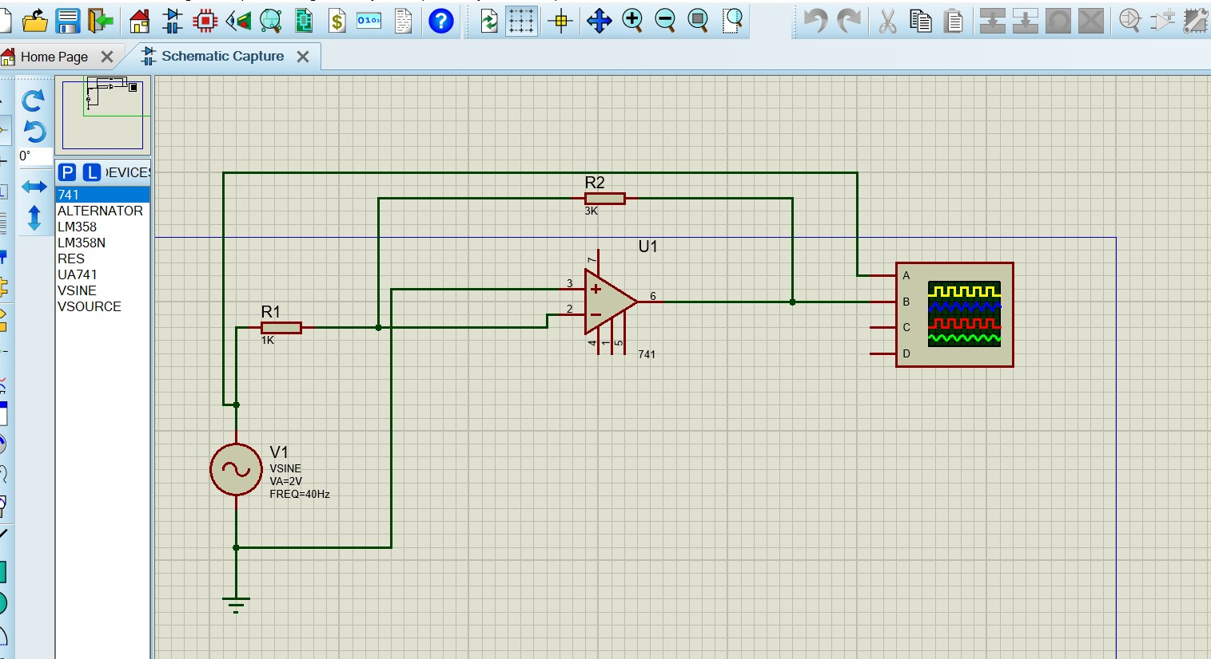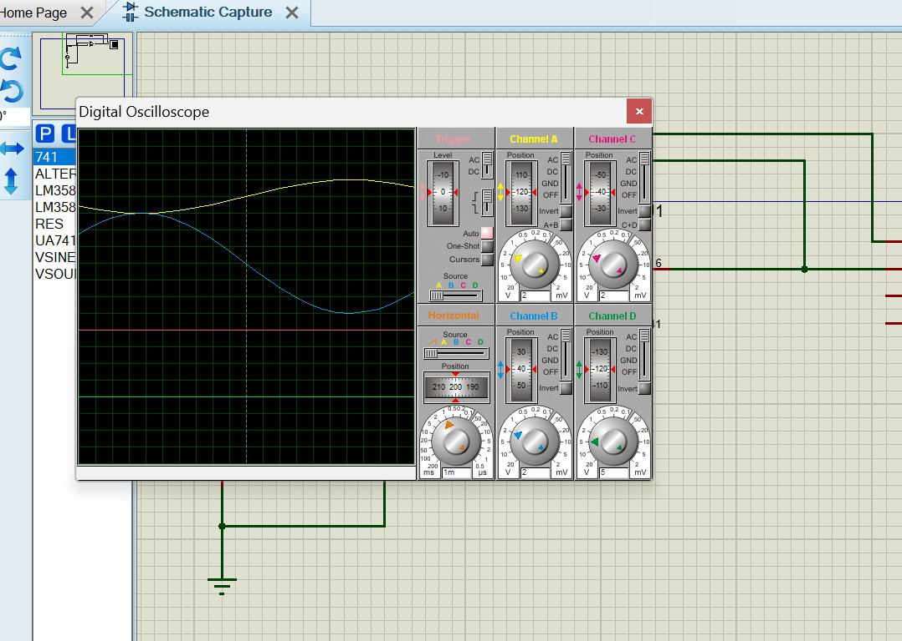

2

Procedure for Non-Inverting Amplifier:
- Wire up the circuit as shown in the figure below on the breadboard.
- Give the input to the non-inverting terminal of the op-amp and simultaneously display the input and output on the oscilloscope.
- Draw the input & output waveform at the end of the lab.
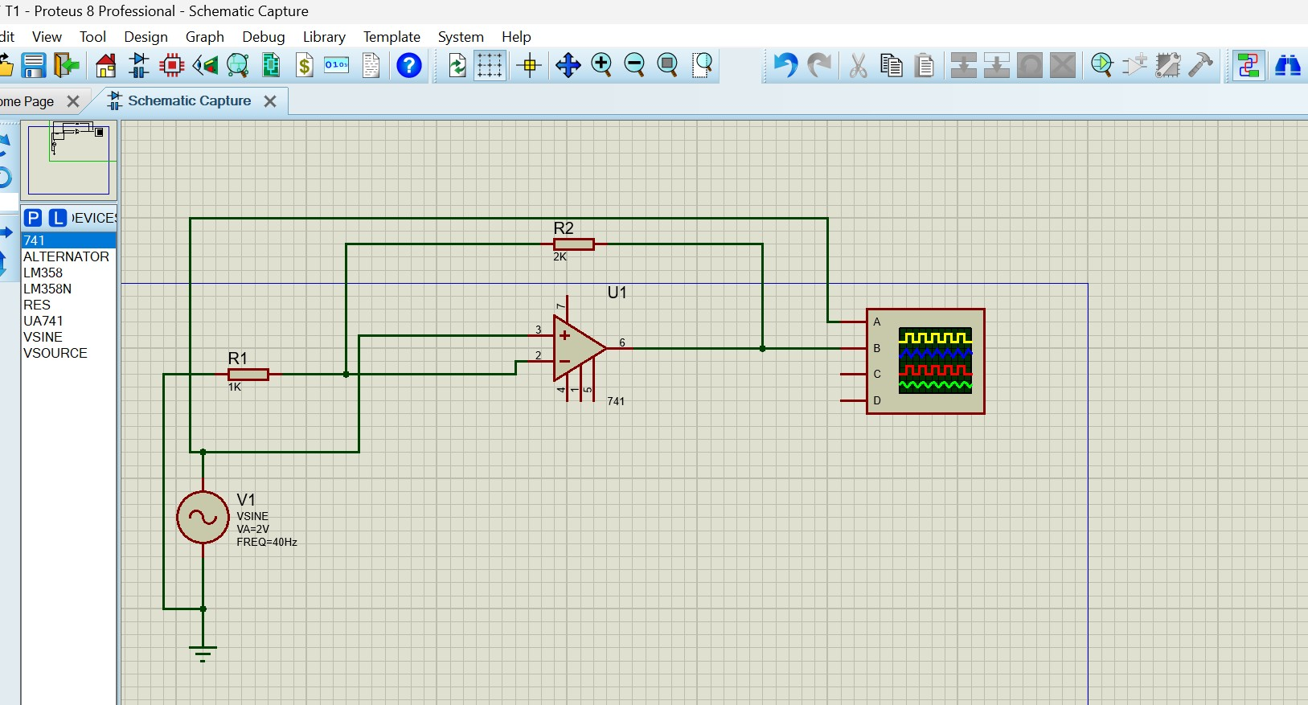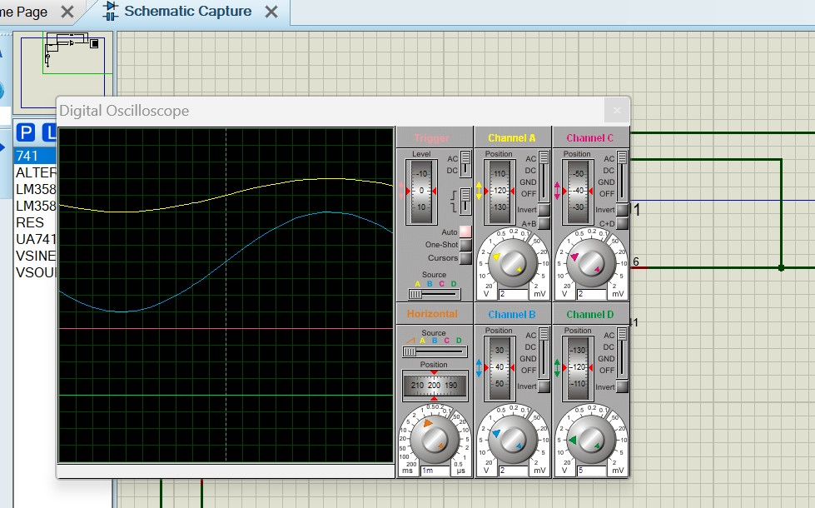

3

